THE PRODIGAL SON’S HOUSE

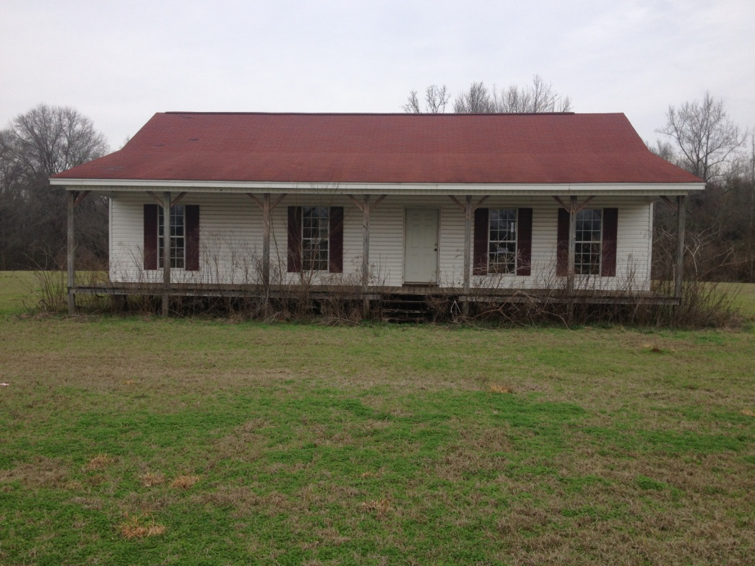

“But we had to celebrate and be glad, because this brother of yours was dead and is alive again; he was lost and is found,” Luke 15:32

10784 River Rd
Selma, Alabama 36703
Andre.S425849@gmail.com

I am an alcoholic. In 2011 I finally surrendered to the fact that I was out of control. What started out as fun and games for me 15 years prior turned into a physical addiction and mental obsession. After numerous blackouts, alcoholic seizures, six DUI arrests and diversion programs, and thousands of dollars paid for restitution, probation, community corrections, I still did not think I had a problem.

I knew that one more strike with the law would lead to prison and/or possible death. I confessed my inability to stop drinking to a helpful judge and he sent me to get the help I needed at the VA Medical Center in Tuscaloosa, Alabama. That was where my life began to change. I started to understand more about alcohol and the damage it had done to me. I was detoxed and given recovery tools to use after treatment; I took full advantage of those tools. I Joined Alcoholics Anonymous (AA) and found a new spiritual way of living. Even though AA does not require that I believe in God, this is where I found God. God's grace brought me to AA and ironically, the program brought me back to God. This was the same God my parents tried to connect me to growing up, but I did not seek after Him.

I did not enjoy being a controlled social drinker. When I drank more and was the life of the party, I enjoyed the attention, but soon my drinking was out of control. I depended on alcohol for my sense of strength and courage to succeed, but it was false. I have since learned to turn to God for all these things and more. God taught me humility and He became my primary source of strength instead of using alcohol. I understood that God was to be praised and given all the glory in the good times as well as the bad. God had a purpose for me to carry a message. That message is that one can be free of alcohol. I share my testimony of sobriety, and how God gave me His grace to change. Initially the alcoholic may reject God, but often turns to God as his higher power after seeing His power change lives in AA.

God helped me to realize that His gifts should be used selflessly to help others. That's where I ultimately found freedom from bondage. I have been involved in service work at AA groups and have been mentored as well. I took what I had learned and started another AA group. That group is currently going strong and assisting the community and veterans. I am involved in transporting vets from the VA in Tuscaloosa, where I initially received my help, to AA meetings. God has opened many other doors where I have had the opportunity to lead AA meetings. Other involvements have been at informational meetings and motivational groups at the VA. I have helped people in need at court hearings, hospital placements, community projects, and charity work.

I have seen the great need for halfway homes that are Christ-based for the homeless who have life controlling problems. There is a great need for these men to be discipled and return to society as men of integrity who contribute and are examples of lives who have been changed by God. Thus, it is my goal to work toward establishing a home in the Selma area that would offer the opportunity for this to happen. I ask for your prayers and help as other men and women work along with me toward this worthy ministry.

We Need the Following Materials/Supplies
- Notebooks
- Pens/pencils
- Bible workbooks/worksheets
- Bibles
- Bunk beds/mattresses
- Furniture – couches, chairs, desks, tables
- Dishes, pots and pans, utensils, flatware
- Linens – sheets, towels, blankets
- Pool table/ping pong table
- Big books/12 X 12/12 Steps
- Clocks, pictures
- Outdoor furniture
- Seeds, gardening tools, fertilizer
- Livestock, chickens
- Office supplies, computers, printers, fax, file cabinet, phone
- Urinalyses, breathalyzers
- Television, DVD player
- Refrigerator, stove, deep freezer
- Lawnmower

Purpose Statement

Our purpose is to effectively encourage once hopeless and addicted men who had lost their footing in society to once again become productive godly men with integrity, and to guide these men to live by the spiritual principles of God in order to become useful to their families and also their communities again as husbands and fathers, and working productive members of the community and society as a whole.
Members of the Board

Overview of Services
- Christian based mission
- Must have had successful completion of a minimum of 28 days of treatment
- 3-6 months stay
- After one month, clients will pay 30% of income
- Misdemeanors and nonviolent felons only, per discretion of the board on a case-by-case basis; new charges result in immediate expulsion
- No major physical health issues
- Mental health must be stable and be able to take own medication
- All residents will be subjected to random urinalysis/breathalyzer
- Positive urinalysis/breathalyzer will result in immediate expulsion
- Interviews will be completed on all potential clients to determine eligibility
- Bible lesson and verse memorization
- Chapel
- AA group every day
- Sunday Church
- Three phase system: 2 months per phase based on clean and sober time, completing assigned chores, and following rules.

Rules
- Free time on Saturday
- Visitation on Sundays only in designated areas
- Chores to be assigned and completed daily except Saturday
- No smoking except in designated areas at designated times
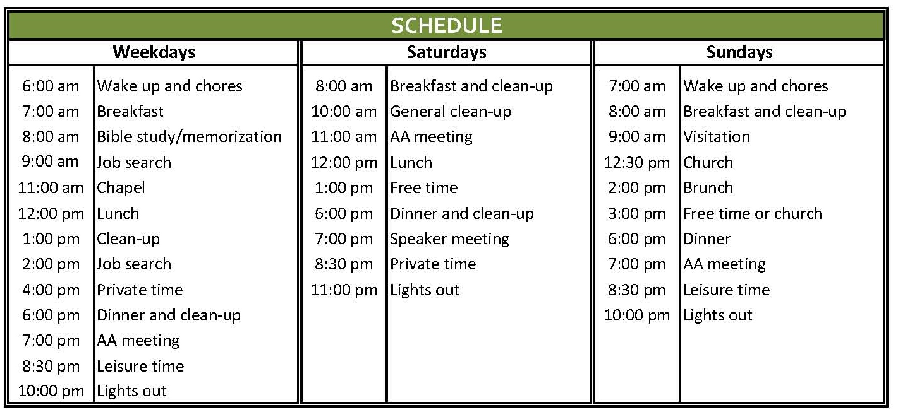
- No narcotics or addicting substances. No tolerance in regards to positive urinalysis or possession. Infractions will result in immediate discharge.
- Anyone under the influence of substances will be asked to leave, pending the discretion of the board
- Any verbal or physical threats will lead to immediate discharge
- No sexual harassment
- No borrowing or lending money or any other thing that can be used for money
- No eating in rooms
- Sleeping is only done at designated times and in your room
- Appropriate clothing to be worn at all times (pajamas only in bedroom)
- No weapons (pocket knives, razor blades, brass knuckles, guns, mace or any object that could bring harm to another)
- All cell phones will be collected at the beginning of each group, if it becomes an issue
- Computers used during designated times and only for job research
- No porn. Any use will result in immediate discharge.
- All suspicious mail will be subject to inspection
- Any paraphernalia will be confiscated and turned over to the authorities
- Searches of residents and rooms will be at the discretion of staff
- No energy drinks, no mouthwash with alcohol, no hand sanitizer

